May 11, 2023
Crossville Studios
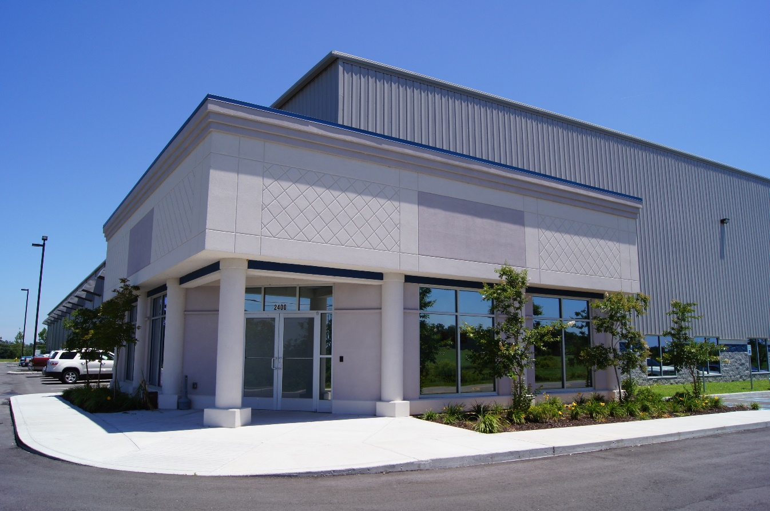
Hollingsworth TL-174 Building
Huntington Park Drive Loudon, Tennessee

Mr. Tom Mann
Hollingsworth Companies
Two Center Plaza
Clinton, TN 37716

Dear Tom,

Crossville Inc. (“Tenant”) has authorized Newmark to secure proposals and other pertinent information regarding their Tennessee facility requirement. After conducting a study of the market, our client has expressed an interest in your project. Please prepare a proposal for your property that incorporates the following terms and conditions. Please submit your written response no later than May 22, 2023.

Tenant
Crossville, Inc.

All offers herein based on the assumed bankable credit of the tenant entity using the Landlord’s standard credit approval procedures based on the most recent (3) years of audited financials. Landlord will sign non-disclosure agreements as required by Tenant.

Use
Storage, distribution, and general office administration.

Agreed.

Building
Huntington Park
Loudon, TN

Hollingsworth TL-174 Building.

Premises
Approximately +/- 130,424 square feet on 16.16 acres. The space is to be measured by ANSI/BOMA Z65.1 standard.

Agreed.

Lease Term
Please base the proposal on five (5), seven (7) and ten (10) year lease terms.

Seven Year Term:
Base Building Lease Rate: $6.97/SF/YR NNN, CPI annual adjustment (3% minimum), and
Upfit Lease Rate: $0.78/SF/YR NNN, CPI annual adjustment (3% minimum)

Ten Year Term:
Base Building Lease Rate: $6.47/SF/YR NNN, CPI annual adjustment (3% minimum), and
Upfit Lease Rate: $0.63/SF/YR NNN, CPI annual adjustment (3% minimum)

Include list of landlord improvements and pricing for the improvements in this section.
Costs are included in the Upfit Lease rates above. See Exhibit A for Office Layout
- an office area with 2 - 12 x 12 offices, restroom, breakroom, conference room and storage room
- warehouse lighting with LED fixtures with motion sensors at 35 fc
- two battery disconnects for forklifts with eyewash station.
- one air change per hour in warehouse
- 5 dock doors with 30,000 # mechanical pit levelers, dock light, bollards
- 5 electrical drops in warehouse
- Lapidolith floor seal in warehouse

NNN’s are estimated at $ .65 SF/YR
Taxes $ .45 SF/YR
Insurance $ .10 SF/YR
Maintenance $ .10SF/YR

Commencement Date
December 1, 2023, Tenant shall have 30 days prior to lease commencement for installation of furniture, racking, cabling, etc.

Lease and Rent Commencement set at September 1, 2023, tenant shall have the month of August (or sooner) for installation of furniture, racking, cabling, etc. while offices are being built.

Rental Concessions
Please state what rent abatement will be offered and specify if operating expenses and taxes will also be abated during the rent abatement period.

There will be 30 days of early occupancy available, the tenant is responsible for taxes, insurance, and utilities during the early occupancy.

Rental Rate
State the rental rate for your building. Please identify if this is a gross or net rate and what other charges, if any, will be in addition to the base rental rate (i.e., taxes, insurance and cam).

See in Lease Term section above.

Operating Expenses & Real Estate Taxes
Provide a breakdown and estimate of the actual operating expenses and real estate taxes for the building. Additionally, all controllable expense increases to be paid by tenant in excess of the first year’s actual expenses shall be capped at four (4%) per year on a non-cumulative basis. Landlord shall remain responsible at Landlord cost to repair and maintain the structure including floor, foundations, roof, below grade plumbing, fire sprinkler and walls, landscaping and common areas.

All Operating Expense accounting shall be consistently applied from year to year. Tenant shall have audit rights of Landlord’s Operating Expense accounting on an annual basis. If an audit shows a discrepancy of greater than 4%, Landlord shall pay the cost of the audit as well reduce the operating expenses going forward.

See in Lease Term section above.
The NNNs are controlled by the Tenant. The taxes (and insurance if requested) will be charged to the Tenant with no handling charge. Landlord will maintain structure and roofing at Landlord’s sole expense, all other maintenance is under the control and responsibility of the Tenant. The Landlord will not charge any management or common area fees for this project.

Landlord Improvements
Landlord shall provide the following improvements upon lease commencement.
- an office area with 2 - 12 x 12 offices, restroom, breakroom, conference room and storage room
- warehouse lighting with LED fixtures with motion sensors at 35 fc
- two battery disconnects for forklifts with eyewash station.
- one air change per hour in warehouse
- 5 dock doors with 30,000 # mechanical pit levelers, dock light, bollards
- 5 electrical drops in warehouse
- Lapidolith floor seal in warehouse

See Upfit Lease Rate in Lease Term section above.

Code Compliance
Landlord shall make all systems in compliance with all local codes.

Agreed.

Parking
Please detail number of parking spaces for tenant.

There are 40 car spaces provided, see Site Plan drawing below for details.

Sublease & Assignment
Tenant will require the right to sublease or assign any portion or all of their premises to a subsidiary or affiliated company or to any corporate successor (upon merger or consolidation) without the consent of Landlord. Should it be necessary to sublease to third parties, Landlord will provide approval, which shall not be unreasonably withheld or delayed. Under any sublease scenario, Tenant will retain the right to any and all profits for such sublease.

Agreed.

Building Condition
Landlord shall warrant the roof, HVAC systems, structural components, and all electrical and plumbing systems serving the premises for the first twelve (12) months of the lease term. Landlord will pass on all additional warranties to Tenant.

Agreed.

Right of First Refusal
NA

Non-Disturbance Agreement
Tenant will require a non-disturbance agreement from the owner and all mortgagees. Such agreement shall be mutually agreeable after prior review by Tenant and the respective Lender and shall be delivered contemporaneously with the execution of a lease.

Agreed.

Brokerage
Landlord recognizes Newmark as the Broker representing the Tenant and said Broker shall be paid a commission per a separate written agreement.

Agreed.

The submission of this Request for Proposal is non-binding. A lease shall not be binding and in effect until a mutually agreeable lease document has been executed by both parties.

Agreed. All offers if not accepted by June 16, 2023, are automatically withdrawn.

If you have any questions, please do not hesitate to give us a call.

Sincerely,

Bob Luttrell
Managing Director

cc

EXHIBIT A
FACILITY PLANS
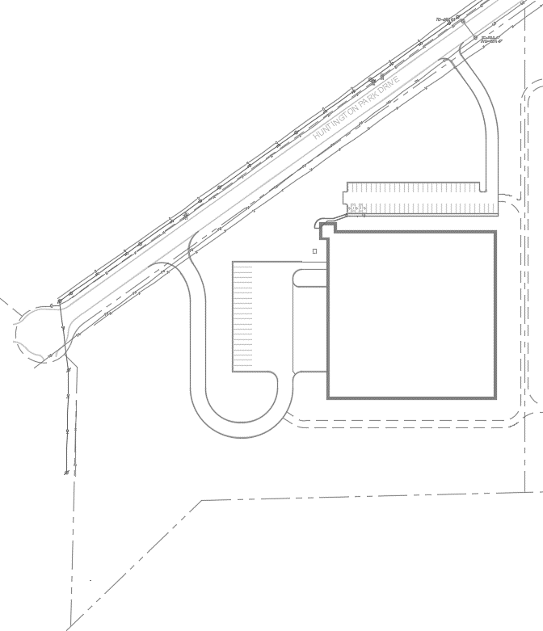
SITE PLAN

(40) CARS

(20) TRAILERS
(12) DOCKS
RAMP
FUTURE EXPANSION
43,200 SF
TL-174 BUILDING
130,424 SF
OVERALL FLOOR PLAN

FIRE PUMP
OFFICE/ENTRY
(12) DOCKS W/
LEVELERS, LIGHTS & SEALS
OFFICE PLAN
OFFICE UPFITS 1,824 SF

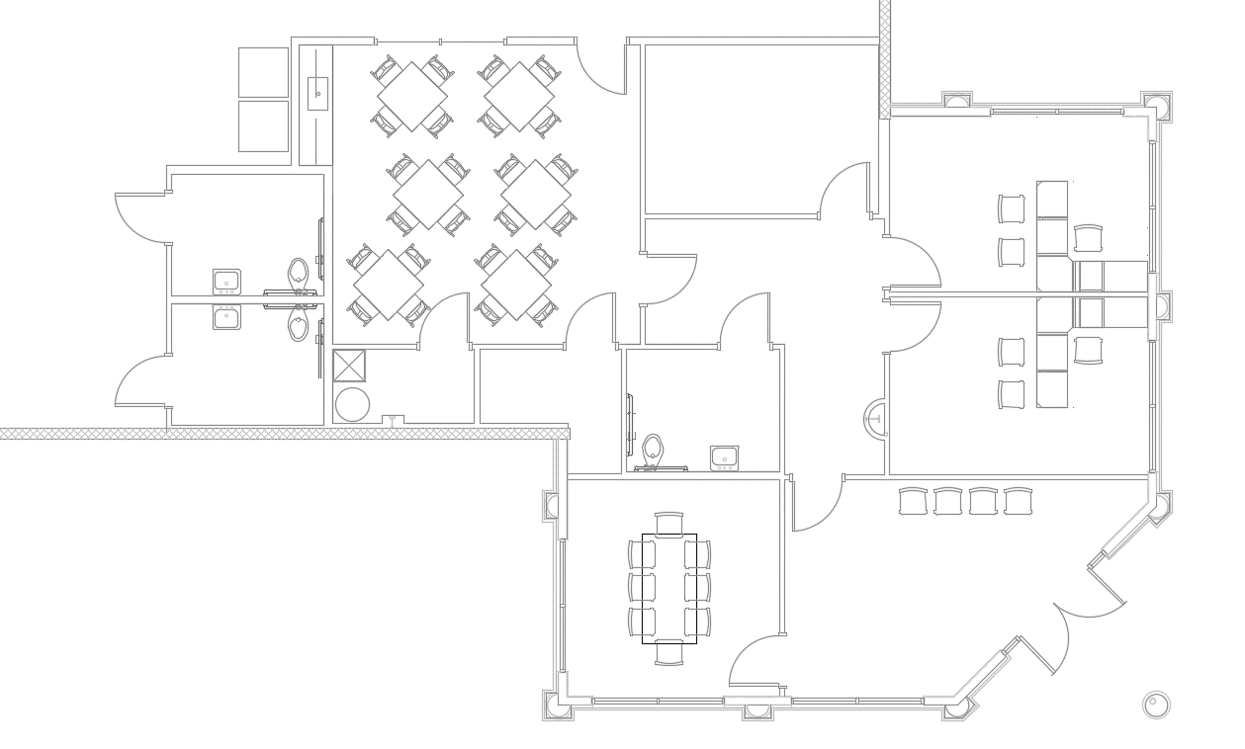
CONF
LOBBY

OFFICE
TOILET
TOILET
IT
JAN

TOILET
BRK. RM.

V
OFFICE
STORAGE
V
WAREHOUSE

